
Draft Training Schedule

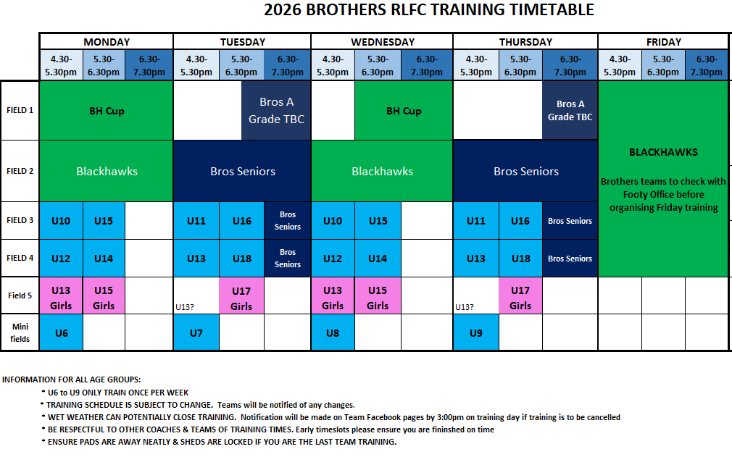
CONTENTS
WELCOME TO THE 2026 SEASON! 5
Vision Statement 5
Mission Statement 5
QRL POSITIVE ENVIRONMENT PROGRAM 5
NATIONAL CODE OF CONDUCT - SUMMARY OF OFFENCES 6
2025 BROTHERS RLFC FOOTBALL BOARD MEMBERS 7
COACHING OVERSIGHT 7
SENIOR COACHES 7
REGISTRATION 8
Returning Players 8
New Players 8
Clearances (Transfers): 8
REGISTRATION FEES & INCLUSIONS 9
Juniors 9
Seniors 10
Registration Fee Invoices - Revolutionise 10
Payment of Fees 10
Outstanding Registration Fees 11
INSURANCE 11

WELCOME TO THE 2026 SEASON!

Dear Parents, Carers, Team Staff, Supporters and Players,
Brothers RLFC will be fielding teams from Under 6 to Under 17, including Girls teams (U13, U15, U17), as well as Under 19, Reserve Grade, A Grade Men, and Open Women in the RLTD competition.
The following information has been provided for your benefit. Please take the time to familiarise yourself with the contents of this booklet and enjoy the 2026 Rugby League season with Brothers.

Our Club’s Vision and Mission Statements clearly articulate what we are about.

Vision Statement
Our Club will provide leadership, support, and direction to the development of Rugby League in the Townsville region. We are a Club backed by strong family values, creating a culture that is nurturing, supportive and inclusive for all our members. Where enjoyment of the game is as important as winning, where participation with one Club is lifelong, and where young people become better people.

Mission Statement
We will provide leadership through effective Club governance, financial self-reliance, the provision of an inclusive, supportive family orientated environment for our members, our focus on one Club for life and our commitment to the development of our great game of Rugby League.

QRL POSITIVE ENVIRONMENT PROGRAM
Enforces the existing National Code of Conduct
What is the Program - A fully aligned statewide program that empowers volunteers to proactively tackle behaviour issues and create a positive environment at Community Rugby League games.
Why do we need it? - We need this program to prevent poor behaviour and violence before it escalates and continue to allow our game to be promoted as a safe, positive and inclusive sport. Anyone attending matches needs to be aware that if they behave poorly, the team on the field may have their game abandoned, lose competition points or be removed from the competition and the individual may be excluded from attending QRL games and events for a period of time.
Full details of this program can be found at:
https://www.qrl.com.au/clubhouse/positive-environment-program/

NATIONAL CODE OF CONDUCT - SUMMARY OF OFFENCES
Link to full details - National Code of conduct
ALL Clubs are responsible for the conduct of their players, parents/carers, coaches, officials and spectators.
“Rugby League is a game for all, with a place for all. It is a sport built by the community and bound by the values of being inclusive, positive, united and disciplined. The Rugby League Code of Conduct is a direct reflection of the behaviours and standards that all players, parents, coaches, match officials, spectators and volunteers, expect the game to uphold. It is not only our duty, but everyone’s duty, to ensure the environment we create and expect abides by these rules, regardless of age, gender and ability.” Peter V’landys – Chairman ARLC
No person(s) attending a match, function, or Club related event or activity shall:
- Use offensive or obscene language to any participant.
- Enter the Field of Play or the Playing Area during the course of a match without the prior approval of the Ground Manager appointed by the home Club and/or League.
- Excessively dispute the decision of a Referee or Touch Judge either during or after a match.
- Assault, or act with aggression, to any person/s.
- Behave in a way contrary to the Code of Conduct and/or the spirit of the game.
- Behave in a way which disturbs the enjoyment of a match, function, activity or event by any person/s, or brings discredit to any Club, League or the game.
- Act in such a way as to exhibit racial intolerance, by language or other conduct, to any person/s.
- Refuse to accept the reasonable direction of the Ground Manager, official of the team/ Club which that person is supporting, or official of the home Club and/or League.
- No person/s may make comment or take actions that bring discredit to any person, Club or league through any social media outlet.
Clubs are responsible for the conduct of their players, parents/carers, coaches, officials and spectators.
Breaches of the Rugby League Code of Conduct may result in penalties, including but not limited to:
› Suspension of a match and/or
› Termination of a match (including potential forfeiture of competition points) and/or
› Monetary fines and/or
› Suspension of a participant on a temporary or permanent basis and/or
› Suspension of a Club, League or Association on a temporary or permanent basis
These penalties are in addition to any penalty which may be imposed by the relevant governing League bodies.

2026 BROTHERS RLFC FOOTBALL BOARD MEMBERS
Executive
President – Shaun Valentine
Vice President – Michael Parker-Walshe
Secretary – Tara Meres

Board Members

Scott Dowd
Michael Hilescher
David Rath
Steve Olsen
Keira Karakyriacos
Tennyson Elliott

Staff

Development Officer – Scott Kyle –development@brotherstsv.com.au
Mob – 0402 381 127

Football Operations – Kerry Winton football.admin@brotherstsv.com.au
Mob- 0408 889 194
Melissa Thorburn juniors@brotherstsv.com.au
Mob – 0407 731 647

Office Ph : 07 4773 8000

SENIOR COACHES
A-Grade – James Tamou
Reserve Grade – Craig Karakyriacos
Women – Pou Leiua
U19 – Russell Bawden

Brothers Website : There is some great information and resources that all Parents and Volunteers should take the time to read. Click the link below

https://brotherstsvrlfc.com.au/policies-resources/

REGISTRATION

EVERYONE involved in the great game of Rugby League MUST register online via PlayRugbyLeague.com – this includes Players, Coaches, Trainers (First Aid Officers and LeagueSafe/Water Runners), Managers, and other members involved in facilitating the Game.
Under the rules of the RLTD, NEW and TRANSFERRING Player registrations shall not be accepted until after Sign-on day. New, transferring, and returning Player registrations will be accepted from Sign On Day onwards (31st January 2026), until teams are at capacity.
Returning Players have until the day prior to Sign On Day to secure their position for the upcoming season, before registrations are also opened to New and Transferring Players.
New Players are those who have never played Club rugby league before. New Players may register to Brothers RLFC prior to Sign On Day, HOWEVER we cannot formally accept their registration until Sign On Day. Must also provide and upload ID (Birth Certificate or Passport) showing players Date of Birth.
Clearances (Transfers): Players transferring to Brothers from another club. The Clearance process can start by:
- completing the Clearance Request online at PlayRugbyLeague.com. This can be done by trying to register to Brothers club and the system will prompt you to start a Clearance Request; OR
- by visiting the Brothers Footy Office and request they enter the clearance request manually.

- Once the clearance is approved at all levels, the Player will receive notification via email. They MUST then complete the registration form online at PlayRugbyLeague.com

- VALID ID (e.g. Birth Certificate, Passport, Licence of the player) is required for all NEW and TRANSFERRING Players. Failure to provide ID at time of registration may result in processing delays.

BROTHERS REGISTRATION FEES & INCLUSIONS
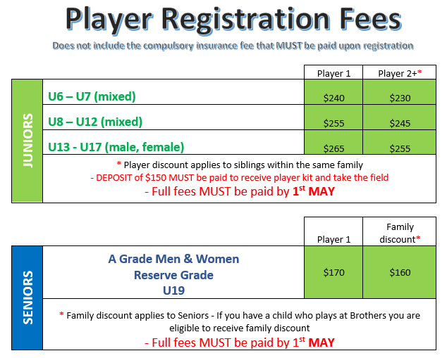

INSURANCE
Insurance is now Mandatory for ALL Players (Juniors and Seniors) and MUST be paid by the participant at time of Registration. This fee is paid directly to the QRL, is NON-REFUNDABLE and is in addition to our Club Registration fee.
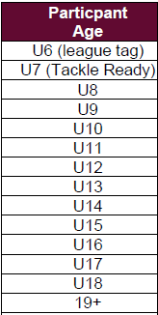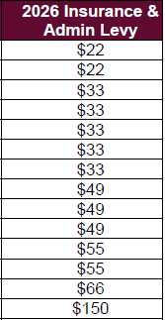
All injuries are to be reported to your team First Aid Officer and Manager so the injury can be recorded in MYSideline.
For all insurance queries, please contact AJG Insurance Broker – contact details can be found on their website: https://www.ajg.com.au/contact
Brothers Club Fees Junior Fees include RLTD registration ($66 - U6 and U7, $82.50 U8 and above), players kit and end of year presentation function
- A minimum deposit of $150 or Play on Voucher is required for Players to be assigned to a team, take the field and receive their player kit. Players will NOT receive their player kit until minimum deposit has been paid.
- Fees must be paid off by 1st May. After this date, players will not be permitted to take the field, until fees are paid in full.
- Players with outstanding fees from previous years will not be assigned to a team until such fees are paid.

Seniors
- Senior Fees include club polo, training shirt, training shorts, ticket to end of year presentation.
Sibling/Family Discount - First child is at full price then $10 off for subsequent children. The $10 discount is a flat amount which does not accumulate with more siblings. Senior Players ARE eligible for the Sibling/Family Discount.

Registration Fee Invoices – Revolutionise
To be successfully registered with Brothers in 2025, you must ALSO register through RevolutioniseSport - https://www.revolutionise.com.au/brotherstsv/registration/
- As we have such a large number of members, we utilise RevolutioniseSport to assist us to keep track of Teams, Player financials, and Player Kit sizes (e.g. Club polo, training tee, etc.)
- Register all Players in 2025 at https://www.revolutionise.com.au/brotherstsv/registration/ and follow the directions on the registration page to RENEW (returning players) or REGISTER (new player)
- Name details must be entered as per PlayRugbyLeague.com profile
- We will sometimes contact members directly from Revolutionise, so you may need to save “Brothers Rugby League Townsville no-reply@revolutionise.com.au” to your Safe Senders list

Payment of Fees
Player Registration Fees can be paid via:
- Online at time of registration though PlayRugby League (part payments NOT accepted via this option). You can pay in full at time of registration, however no sibling discount will be applied, or click “Complete Registration” and make payment via below methods

- Cash/EFTPOS/Credit Card accepted in the Footy Operations Office (end of field 2, Mon-Thurs 4:30-6:00pm during season, though times may vary)

- Part payment using Qld Government PlayOn Sports vouchers are accepted. Check your eligibility or apply for a voucher at https://www.qld.gov.au/recreation/sports/funding/playon and then forward your pdf voucher to football.admin@brotherstsv.com.au for it to be applied to your child’s registration fees. Balance to be paid via Cash/EFTPOS/Direct Deposit

- Direct Transfer of Funds (bank details below)

Acc name: Brothers RLFC
BSB: 084-502
ACC: 01 806 1397
REF: Player name + age group

Outstanding Registration Fees

If a Player has outstanding fees from 2025 or previous years, they will not be permitted to play or be allocated to a team until unpaid fees are paid in full. These players will also not be eligible for a transfer to another club until outstanding fees have been paid.

Facebook Groups
After teams have been split and you know what team your child is in, please request to join your team Facebook group as per the below format.
Brothers TSV U** Team name 2026 – eg Brothers TSV U12 Blue 2026
We ask that NO private messenger groups or WhatsApp groups be started, ONLY use the Facebook groups to communicate with parents and family.

